**Run a Test Case or Entire Test Set**

Test run is done in Test Lab Module

Select the test set first

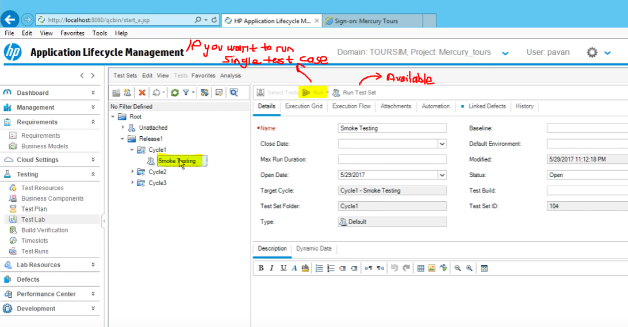

Run button is not available for a single test, click on the Execution Grid, run button will be enabled



Click on run with Manual Runner

This window will be opened

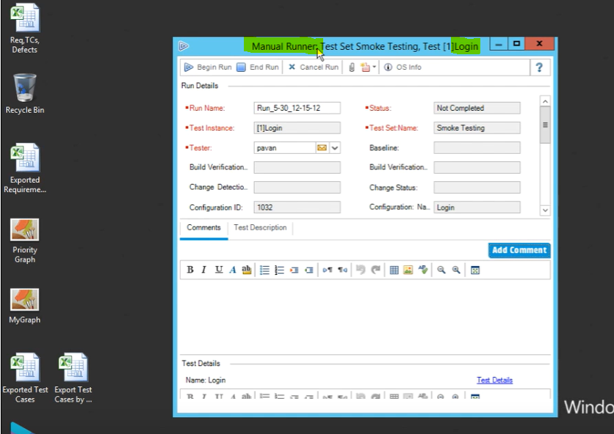

Click on begin run. Enter the actual values for the username and password

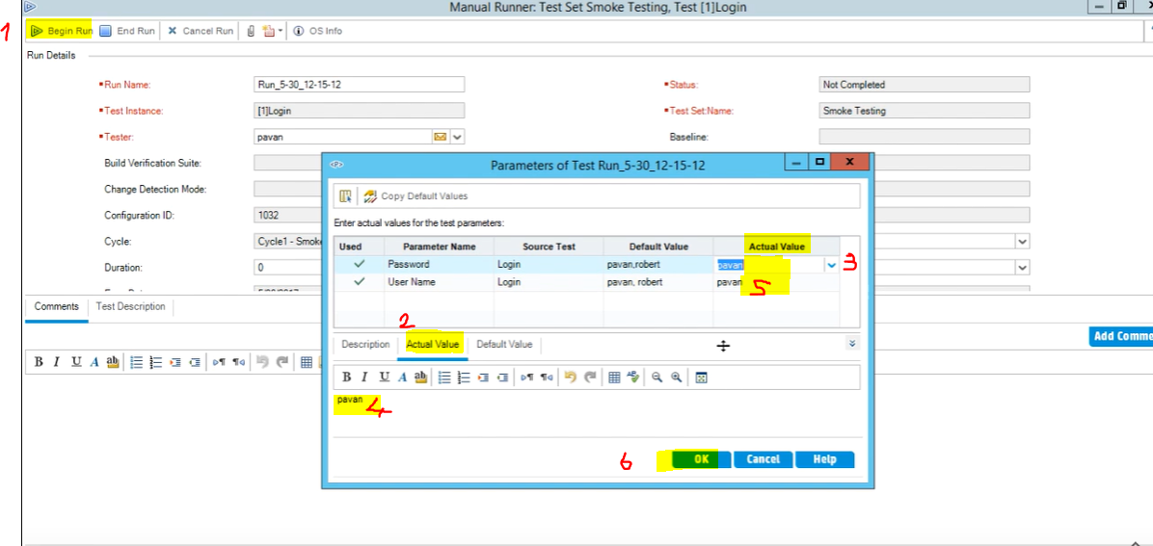

Click Ok

Then you follow the steps, open the browser, go to the website, enter the username

Expected result is “Enter data should be displayed”

If you’re able to type in and what you type is displayed on the username box

Enter the Actual result “same as expected” and mark the status as “Passed”

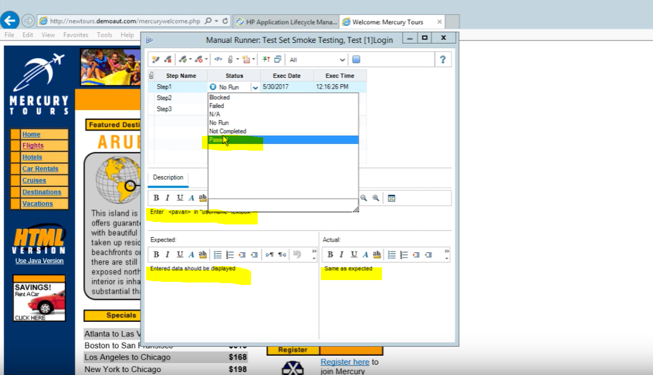

Then do the second step for password, enter the actual result

If it’s the same as expected then mark the status as passed.

Or you can do at the end if all passes you can click on pass icon and select “pass all”

Once you are finished click on stop button

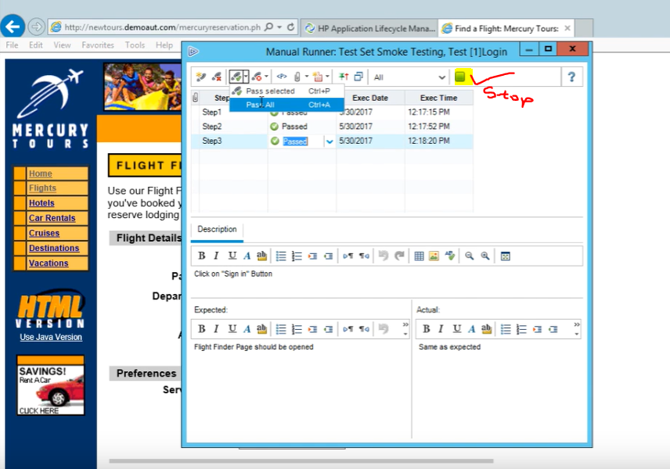

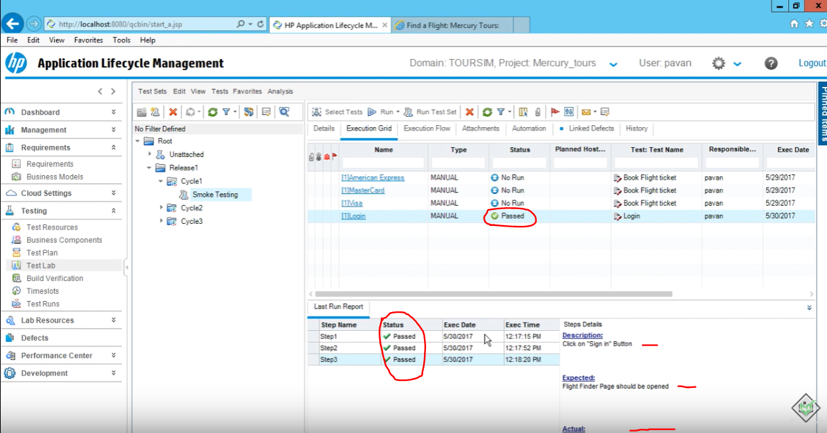

All the Test Runs will be stored under test runs

You can go and view different runs for the same tests

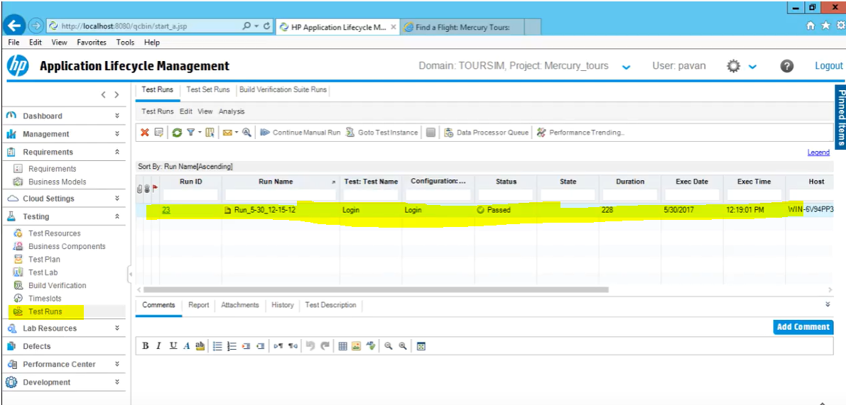

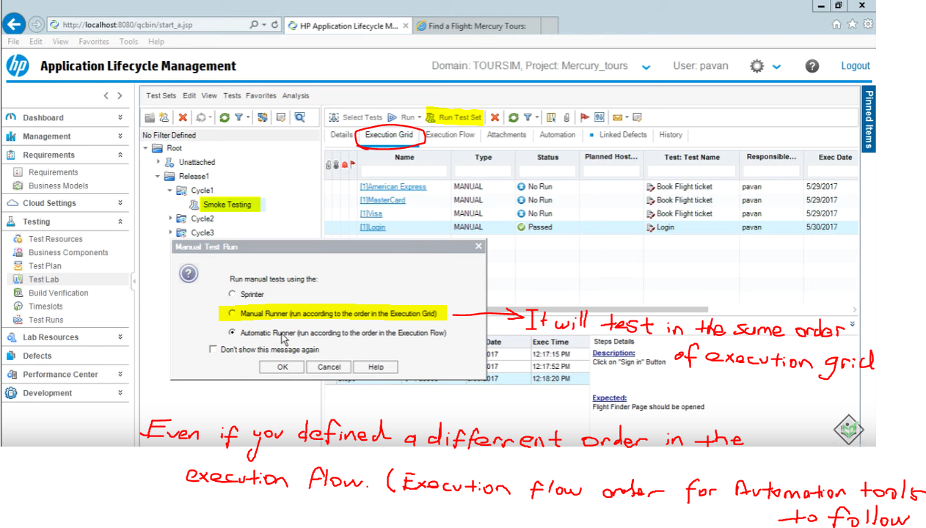

Click ok then click begin run

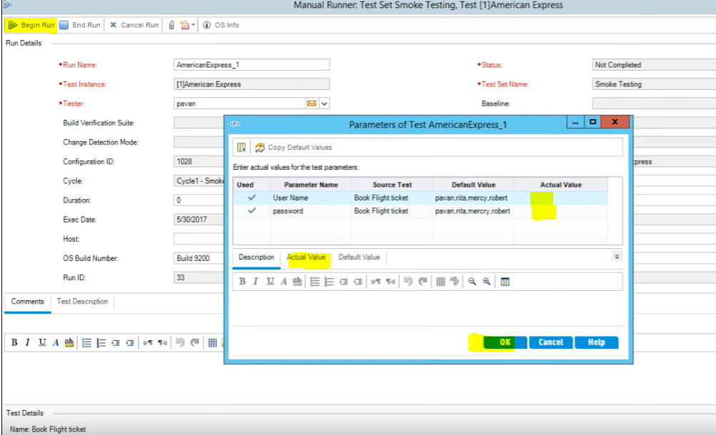

Start from first test and complete all test

